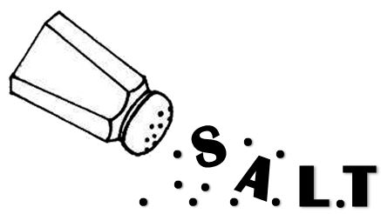
Character Quirks
skill

GOAL: To help students “flesh out” different characters based on body movements, gestures, facials, and voices.

SET-UP: Students can use one of their own interp characters or choose a slip from a jar that lists various characters – old grumpy farmer, business-like efficient nurse, absent-minded professor, etc…

EXERCISE: The students can work in groups of 2 to 3 to come up with a gesture, a facial expression, a movement, and a voice to convey the essence of each of their characters (they all have their own but their groups can help them define their characters). For example, the farmer can walk slowly, hunched over (movement), frequently pull his bandana out of his back pocket to wipe his brow (gesture), listen with his face and eyes all scrunched up like he’s having a hard time understanding (facial expression), and talk with a slow drawl (voice). Then each student can answer one or two random questions from the group in character.

